The Dehydrator
Presented by
The Duncan Band Boosters
January 2026
The members of The Dehydrator Executive Committee would like to invite you to be a sponsor of the 36th edition of The Dehydrator. The Dehydrator is the Band Boosters’ largest fundraiser and always falls on the last Saturday of July. This year, on July 25th, over 400 cyclists will come to Duncan to participate in what TravelOK.com calls “one of the best rides in Oklahoma”. From the starting line at the Simmons Center, our participants ride anywhere from 10 to 80 miles through Stephens County before returning to the Simmons Center for showers and our famous chicken spaghetti lunch. There is a rest station every ten miles along each route. It is a huge undertaking for the Band Boosters and the many volunteers.
The proceeds from The Dehydrator are used by the Duncan Band Boosters to support the Middle School and High School Band programs. Band Boosters use the money that has been raised to pay for things that the school simply cannot afford. This includes cooking and serving meals at marching contests, registration fees, lodging for honor band members, scholarships, instruments, and uniforms. Our band members work hard to support our community, sports programs, and bring accolades to our school system. The Band Boosters also use funds from the Dehydrator to purchase bicycles for the Toy Shop to give to kids in our community.
Please show your pride in these fine young people and be a sponsor today! Your support allows us to run our event at a lower cost, which increases what we are able to do for our band programs and band students, which in turn benefits the entire community.
TO BE OUR SPONSOR please send your sponsorship check made out to “Duncan Band Boosters” with the attached form to: P.O. Box 314, Duncan, OK 73534.
For sponsorship partners who donate in the silver level and above, you will be eligible to have your logo included on our advertising materials/website and complimentary t-shirts. Your check must be received by May 1st, 2026. Sponsors are asked to provide clear black and white camera-ready logo for the t-shirts and a color or black and white logo for the website and other advertising materials. Please email your logo to duncandehydrator@gmail.com no later than May 1, 2026. For sponsorship partners who donate in the Gold level and above, you have the option of setting up an information booth at the Simmons Center (please let me know if you plan to set up a booth so I can ask for a table to be set up for you by the Simmons Center Staff).
If a monetary donation isn’t something you’re able to do, but would still like to help, we need items to fill our rider gift bags (we call them swag bags). Small items for the bags could be promotional items (pens, keychains, notepads), cycling or exercise related items, coupons, etc. We plan on 400-500 riders participating. For more information, or if you’d like to donate items, please email
duncandehydrator@gmail.com
We thank you for all the support you show our community and look forward to your sponsorship this year. If you have any questions, please feel free to contact us. Thank you so much! The Dehydrator Executive Committee and Duncan Band Boosters
The 36th Annual Dehydrator Sponsorships
Bronze Partners $100 - $249  - Name in text on t-shirt back  - Name in text included in sponsor list on website  - Complimentary 1 t-shirt | Silver Partners $250 -$499  - Name/logo on t-shirt back  - Name/logo on website with link to yours  - Name/logo included in slide show inside event center  > Complimentary 2 t-shirt
Gold Partners $500 - $999  - Name/logo featured on t-shirt back  - Name/logo featured on website with link to yours  - Information booth can be set up at Simmons Center  - Name/logo included in slide show inside event center  - Complimentary 4 t-shirts | Platinum Partners $1,000 - $1,999  - Name/logo featured on all media purchases (i.e. advertising)  - Name/logo on t-shirt back (large logo)  - Information booth can be set up at Simmons Center  - Name/logo prominently featured on website with link to your site  - Name recognition on all social media sites  - Name/logo included in slide show inside event center  - Complimentary 6 t-shirts
Diamond Partners $2,000 and Up  - Name/logo featured on all media purchases (i.e. advertising)  - Name/logo on t-shirt back (XL logo)  - Information booth can be set up at Simmons Center  - Name/logo prominently featured on website with link to your site  - Name recognition on all social media sites  - Name/logo included in slide show inside event center  - Complimentary 8 t-shirts | In-Kind Partner  **In-Kind Partners provide support w/o sponsorship  - Name in text on t-shirt back  - Recognition on website  - Complimentary 1 t-shirt up to $500 value  - Complimentary 2 t-shirts over $500 value

Name/Logo Placement on T-shirts
***logo placement is approximate and may vary depending on the number of sponsors and
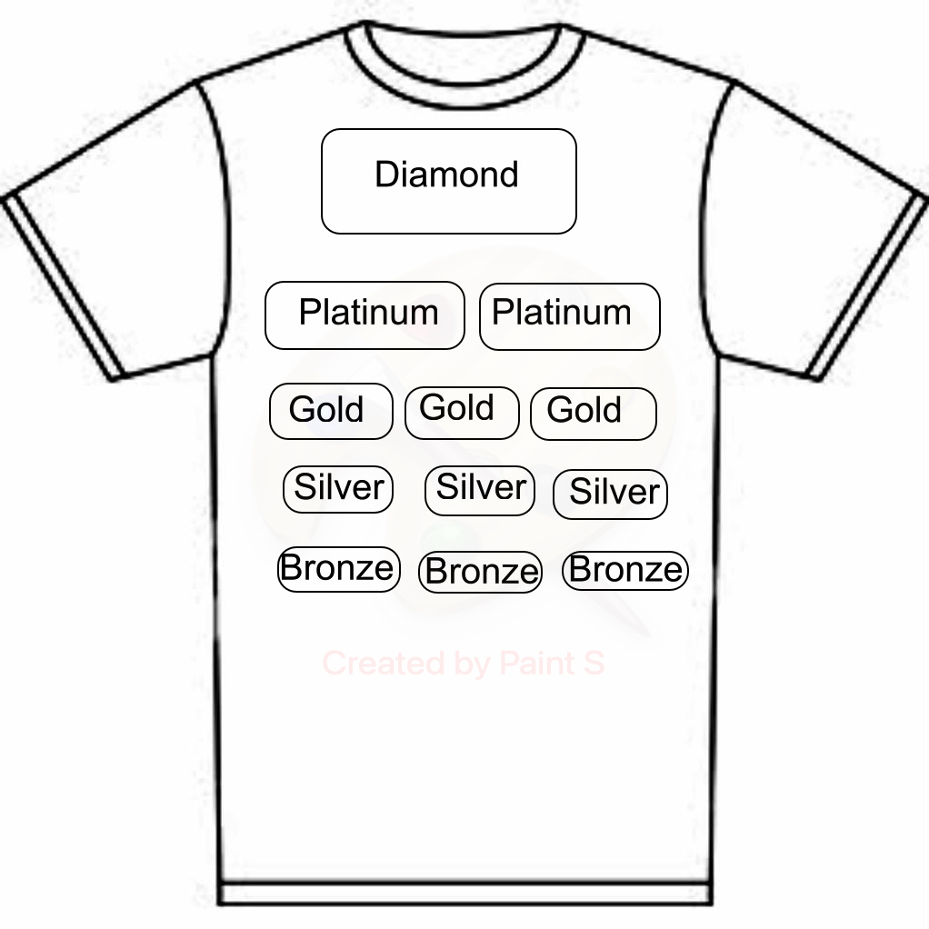
uniqueness of logos.***
Logo is due by May 1st to ensure placement on t-shirt!

================= CUT HERE AND RETURN WITH SPONSORSHIP PAYMENT =================

Sponsor Name____________________________________ Amount__________

Sponsor Address___________________________________________________

City/State/Zip____________________________ Phone___________________

Email_________________________________ Website____________________

Size(s) of Complimentary T-shirts (Available in Adult S to 2XL)

Mail checks to:
Duncan Band Boosters, P.O. Box 314, Duncan, OK 73534
THANK YOU FOR YOUR SUPPORT!!!

